PHASE 1 REPORT

Smartphone Sensor Data Analysis and Prediction of Usage Pattern and Overheating using Machine Learning

Problem Id: 24

Team member 1 (Team Lead)  (Last Name, name, Student ID, University Roll No., email, picture):  Team member 2  (Last Name, name: student ID:, University Roll No email, picture):  Team member 3  (Last Name, name: student ID: , University Roll No email, picture): | Bajaj,Shivansh:2510370470;2028849  2510370470@geu.ac.in    Sharma, Garv : 2510370052,2028716  2510370052@geu.ac.in    Jain,Ketan : 25101281877; 2028743;  25101281877@geu.ac.in  

Problem Description
Smartphones generate a large amount of sensor data such as CPU usage, battery consumption, temperature, memory usage, and other system parameters. Analyzing this data can help understand user behavior and detect potential performance issues such as device overheating.

In this project, machine learning techniques are used to analyze smartphone sensor data and predict device usage patterns as well as overheating conditions. The dataset contains various parameters related to smartphone performance including CPU utilization, battery consumption rate, and other sensor readings. By applying machine learning algorithms such as Logistic Regression and Random Forest, the system learns patterns from historical data to classify the type of usage and detect overheating risks.

This solution can help improve smartphone performance monitoring, prevent hardware damage due to overheating, and optimize battery usage. The project demonstrates how data preprocessing, feature scaling, visualization, and machine learning models can be combined to build a predictive system for real-world applications.
This project extends traditional sensor data analysis by incorporating: - Age Group Prediction (Teenagers, Young Adults, Adults) - Usage Purpose Prediction (Social Media, Gaming, Productivity, Others) - Health Risk Analysis based on excessive usage
Machine learning techniques such as Logistic Regression and Random Forest are used to: - Predict smartphone usage patterns - Detect overheating conditions - Classify users into different age groups - Identify primary usage purpose
Additionally, the system analyzes possible health risks such as: - Eye strain - Sleep disorders - Anxiety and addiction - Reduced physical activity
This solution can help: - Improve smartphone performance monitoring - Provide personalized usage insights - Raise awareness about health risks - Optimize battery and device efficiency

This phase focuses on creation and understanding of the smartphone sensor dataset. The dataset contains smartphone performance parameters such as CPU usage, battery drain, temperature, RAM usage, app activity, and screen time. The collected data is used to analyze smartphone behavior and identify overheating conditions and usage patterns.

Dataset Description
Total Rows: 2000
Total Columns: 22
The dataset includes both numerical and categorical attributes related to smartphone usage.

Dataset Columns
• screen_time_minutes
• accelerometer_mean
• gyroscope_mean
• touch_events_per_minute
• battery_consumption_per_hour
• cpu_usage_percent
• background_apps_running
• device_temperature_c
• usage_class
• overheating_flag
• cpu_usage
• battery_drain
• temperature
• memory_usage
• screen_time
• gaming_time
• social_media_time
• Age_Group
• Usage_Type
• Health_Risk
• total_usage
• usage_intensity

Architecture of Dataset Collection
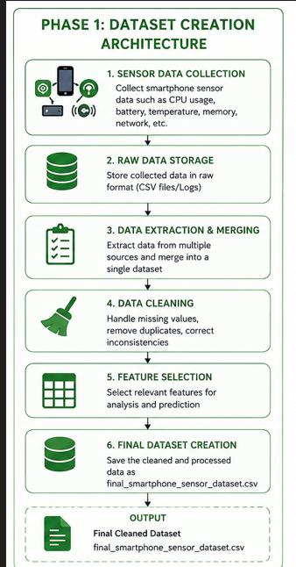

Sample Dataset Preview
screen_time_minutes accelerometer_mean gyroscope_mean \
0 NaN NaN NaN
1 NaN NaN NaN
2 194.0 9.786169 0.254396
3 NaN NaN NaN
4 342.0 8.825635 3.176505
touch_events_per_minute battery_consumption_per_hour cpu_usage_percent \
0 NaN NaN NaN
1 NaN NaN NaN
2 55.0 28.041622 26.0
3 NaN NaN NaN
4 49.0 9.805410 28.0
background_apps_running device_temperature_c usage_class \
0 NaN NaN NaN
1 NaN NaN NaN
2 27.0 44.825816 0.0
3 NaN NaN NaN
4 29.0 38.589571 1.0
overheating_flag ... temperature memory_usage screen_time gaming_time \
0 NaN ... 31.0 6323.0 5.85 2.74
1 NaN ... 36.0 2757.0 7.93 3.84
2 1.0 ... NaN NaN NaN NaN
3 NaN ... 43.0 2631.0 8.42 2.00
4 0.0 ... NaN NaN NaN NaN
social_media_time Age_Group Usage_Type Health_Risk total_usage \
0 5.81 Young Adult Social Media Medium 14.40
1 5.59 Teen Social Media Medium 17.36
2 NaN Adult Productivity Low NaN
3 0.02 Teen Productivity High 10.44
4 NaN Adult Productivity Low NaN
usage_intensity
0 2.461538
1 2.189155
2 NaN
3 1.239905
4 NaN
[5 rows x 22 columns]

Modules Used
• Pandas – Data loading and manipulation
• NumPy – Numerical calculations
• CSV File Handling – Dataset storage and management

Platform Required
Python, Jupyter Notebook, VS Code, Anaconda

References
1. https://pandas.pydata.org
2. https://www.kaggle.com
3. Hands-On Machine Learning with Scikit-Learn

